🔴 1. PRP Tube (ACD + Gel)
Classic Two Tube PRP Kit
Contents:
✔️ PRP Tube (ACD + Gel) 10ml – 2 PCS
✔️ Butterfly Blood Collection Needle – 1 PC
✔️ Needle Holder – 1 PC
✔️ Inject Needles 30G 13mm – 2 PCS
✔️ Transport Needle 18G 38mm – 1 PC
✔️ Syringes – 1ml (1 PC), 5ml (1 PC)
✔️ Tourniquet – 1 PC

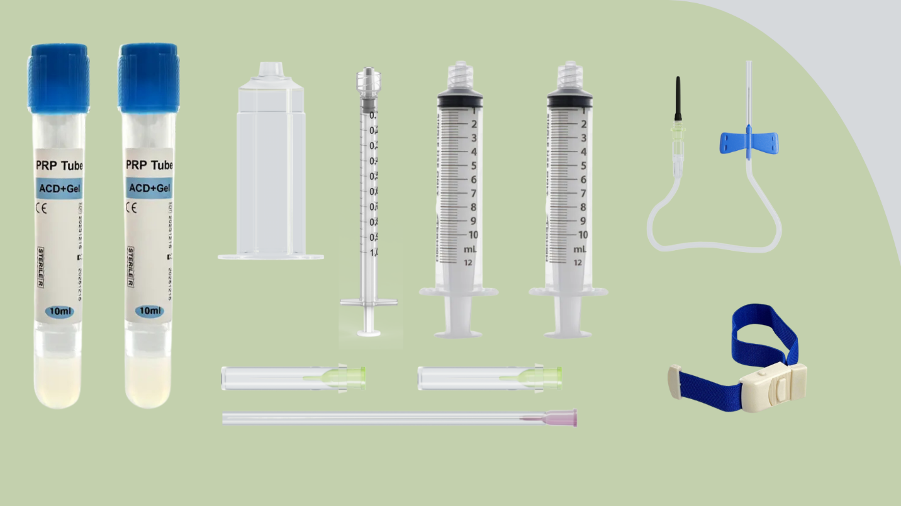

🟡 2. PRP Tube (ACD + Gel + Biotin)
Classic Two Tube PRP Kit with Biotin – For Hair & Skin Rejuvenation
Contents:
✔️ PRP Tube (ACD + Gel + Biotin) 10ml – 2 PCS
✔️ Butterfly Blood Collection Needle – 1 PC
✔️ Needle Holder – 1 PC
✔️ Inject Needles 30G 13mm – 2 PCS
✔️ Transport Needle 18G 38mm – 1 PC
✔️ Syringes – 1ml (1 PC), 5ml (1 PC)
✔️ Tourniquet – 1 PC

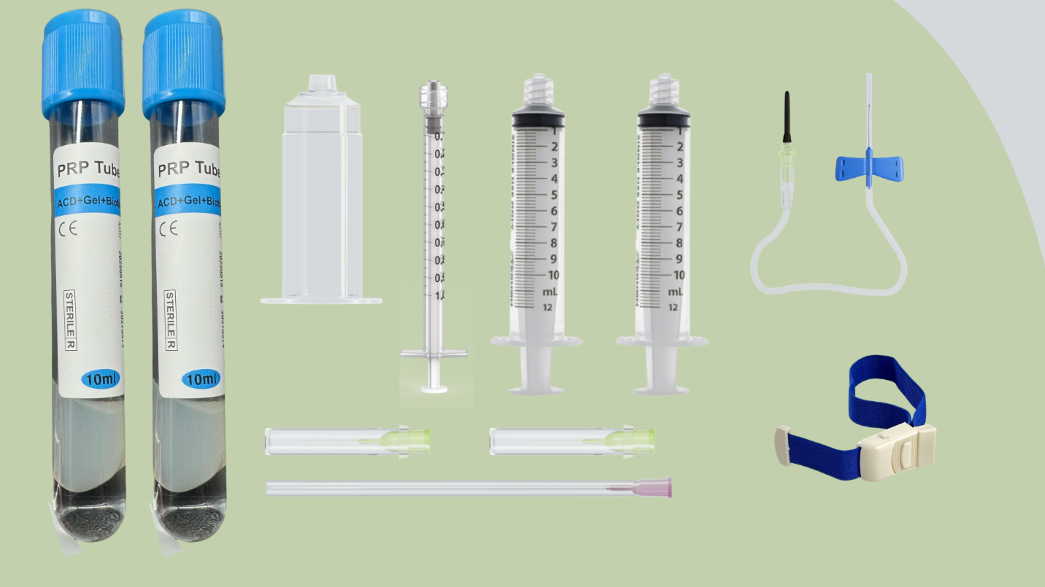

🟢 3. PRP Tube (GFC)
Classic Two Tube PRP Kit – Growth Factor Concentrate
Contents:
✔️ PRP Tube (GFC) 10ml – 2 PCS
✔️ Butterfly Blood Collection Needle – 1 PC
✔️ Needle Holder – 1 PC
✔️ Inject Needles 30G 13mm – 2 PCS
✔️ Transport Needle 18G 38mm – 1 PC
✔️ Syringes – 1ml (1 PC), 5ml (1 PC)
✔️ Tourniquet – 1 PC
